**Modelos:**

Marti: Guillem: 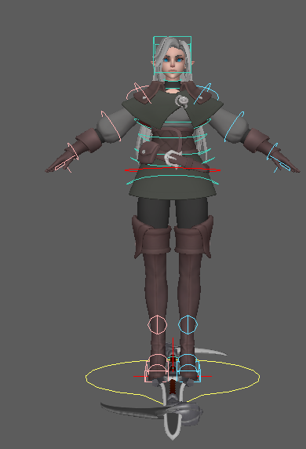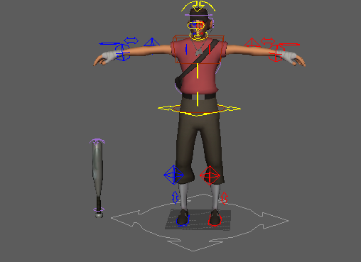

**Animaciones:**

| ANIMACION | TIEMPO |
| --- | --- |
| Idle |  |
| Walk front -- INPUT: X axis |  |
| Walk backwards - INPUT: X axis |  |
| Dodge high attack - INPUT: down + block button |  |
| Evade Low attack (jump in place) - INPUT: up + block button (just press Y = jump) |  |
| Attack quick (short range) - INPUT: X |  |
| Attack slow (long range) - INPUT: A |  |
| Low quick attack (short range) - INPUT: down + X |  |
| Low slow attack (long range) - INPUT: down + A |  |
| Die |  |
| Win |  |

**Sonidos:**

**Efectos visuales (opcional):**

**Fondo:**